|  |  |  |
| --- | --- | --- |
|  |  |  |
| Test steps | Inputs | Expected Results |
| Click on open Whatsapp |  |  |
| Home Page Should Be Open |  |  |
| In Home Page chat Tab Should Be Display |  | Chat Tab Should Be visible |
|  |  |  |
|  |  |  |

Tc -01 pass

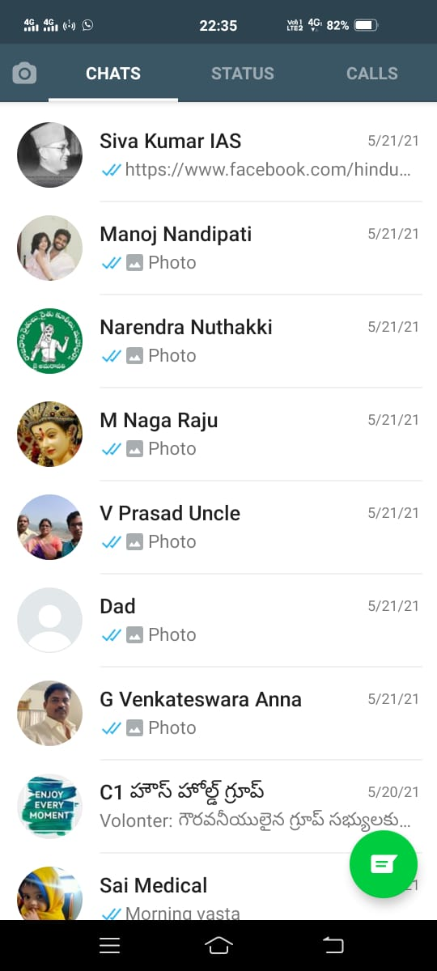  
Tc-02 Satus pass

|  |  |  |
| --- | --- | --- |
| Test steps | Inputs | Expected Results |
| Click on open Whatsapp |  |  |
| Home Page Should Be Open |  |  |
| In Home Page chat Tab Should Be Display |  |  |
| Click on Green Logo |  |  |
| New Page Should Be Open Contact Page |  |  |
| Click on New Contact |  |  |
| New Contact page should open |  |  |
| Enter Name Credentials |  |  |
| Keyboard Should be Display | Give Name :abcd |  |
| Keys'Tab To Contact | 8888888999 |  |
|  | click on done | Saved Credentials show in contact list |
|  |  |  |
|  |  |  |
|  |  |  |
|  |  |  |

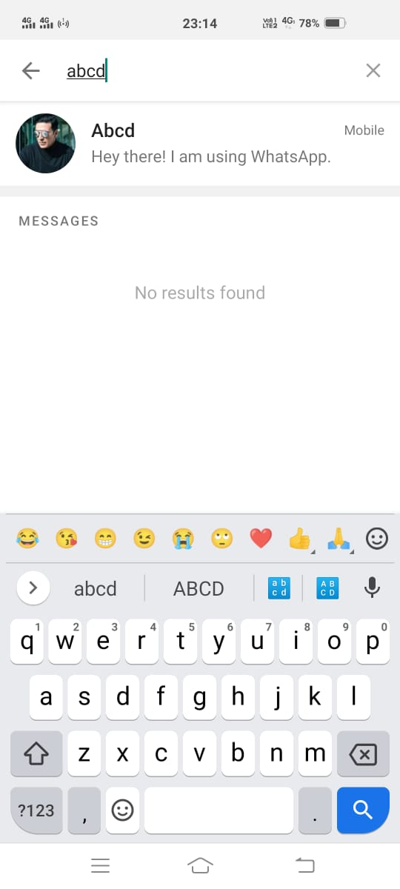

|  |  |  |
| --- | --- | --- |
|  |  |  |
| Test steps | Inputs | Expected Results |
| Click on open Whatsapp |  |  |
| Home Page Should Be Open |  |  |
| Click on Serach Button |  |  |
| New Page Display contact list |  |  |
| Search Name Credientials | ab |  |
| It Show All ab results |  | ab Names list Should Be Display |
|  |  |  |
| Tc-03 Status :pass |  |  |

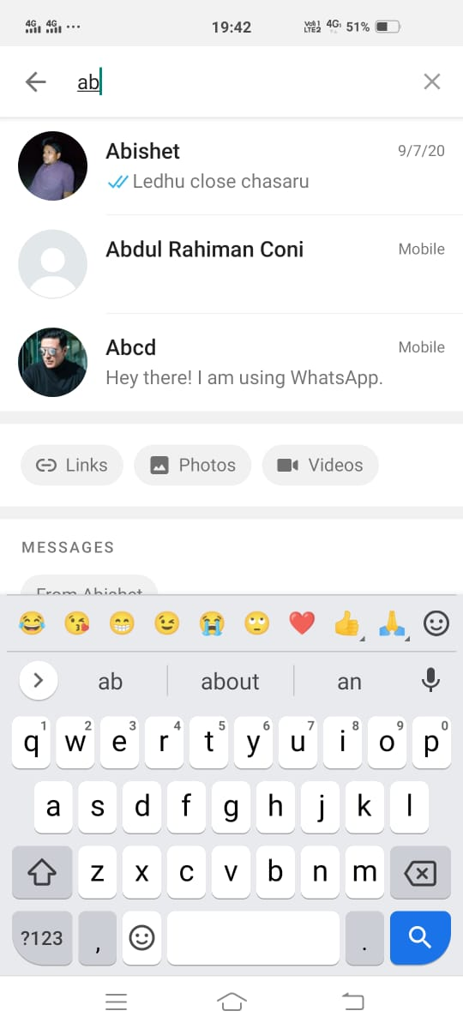

|  |  |  |
| --- | --- | --- |
| Test steps | Inputs | Expected Results |
| Click on open Whatsapp |  |  |
| Home Page Should Be Open |  |  |
| Click on Serach Button |  |  |
| New Page Display contact list |  |  |
| Search number Credientials | 8888888999 |  |
|  |  | contact number Should Be Display |
|  |  |  |
|  |  |  |
|  |  |  |
|  |  |  |



|  |  |  |  |  |
| --- | --- | --- | --- | --- |
| AuthorName | L v Prudvish |  |  |  |
| Module | Watsup |  |  |  |
| Precondtion | Install whatsapp with Internet |  |  |  |
| Testcase id | TestCase Name | Test steps | Inputs | Expected Results |
| Tc -05 | Send Message To Contact Saved | Click on open Whatsapp |  |  |
|  |  | Home Page Should Be Open |  |  |
|  |  | Click on Serach Button | Search number 8888888999 or Name abcd | contact number Should Be Display |
|  |  | Search for message Send |  | Their should visible blank box in Bottom of page |
|  |  | Click On blank chat box |  | KeyBoard Should Be Display |
|  |  | Enter Message In BlankBOx | Hai | It Shoulld Be Print In Box |
|  |  | Search for Right Arrow It shoud Be Green colour Visible | click | It Can Be Move To Send Page |
|  |  | Check It Ticked OR not |  | Can Be visible Single Tick |